Movie Ticket Booking System Project requirements

- Functional Requirements

  - User Module
      - User registration and login
      - Browse movies by city, theater, language, and genre
      - View show timings and seat availability in real time
      - Select seats with temporary seat locking
      - Book tickets and make online payments
      - Receive booking confirmation and e-ticket
      - View booking history and cancel tickets (as per policy)

  - Admin (Super Admin) Module
      - Manage theaters and admins
      - Monitor platform-wide bookings
      - View system logs and analytics

  - Theater Admin Module
      - Theater registration and management
      - Add and manage screens dynamically
      - Create dynamic seat layouts (rows, columns, seat types)
      - Add and manage shows and show timings
      - Set pricing based on seat type and show time
      - View bookings, revenue reports, and seat occupancy

  - Booking & Seat Management
      - Real-time seat availability updates
      - Seat locking for limited time during payment
      - Prevent double booking of seats
      - Support multiple seat types (Normal, Premium, Recliner)
      - Handle seat blocking for maintenance or VIP use

  - Payment Module
      - Online payment integration
      - Payment status handling (success, failure, pending)
      - Automatic seat release on payment failure
      - Refund processing for cancellations
      - Transaction history tracking
Working flow Diagram
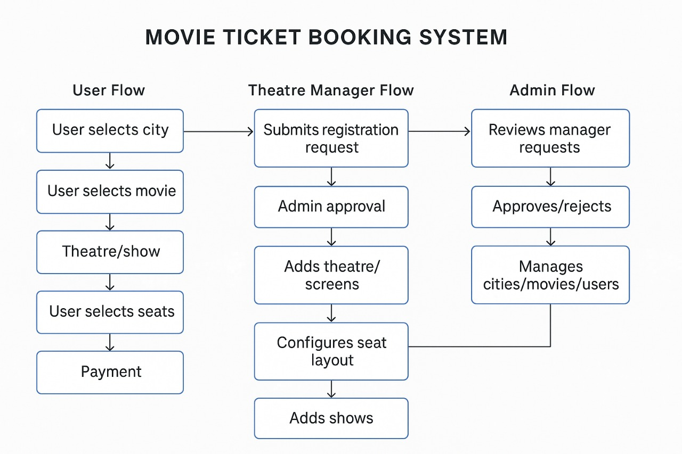

- Non-Functional Requirements
    - High availability and scalability
    - Real-time performance with low latency
    - Secure authentication and authorization
    - Data consistency across online and offline modes
    - Fault tolerance for network failures
    - Secure payment processing
    - User-friendly and responsive UI
    - Logging and monitoring for bookings and payments

- System Constraints
    - One seat can be booked only once per show
    - No overlapping shows in the same screen
    - Payment must be linked to a valid booking
    - Only theater admins can modify seat layouts

- Assumptions
    - Users have basic internet access
    - Payment gateway provides callback APIs
    - AI services are accessible via APIs

